# Uninstall Forticlient VPN 6.3 or lower

KI 0843

**The uninstall will require a reboot.** Please save all your data before completing this step.  
  
Download FortiClient Uninstaller from  [FortiClient Uninstaller.](https://ulcampus-my.sharepoint.com/:u:/g/personal/service_deskitd_ul_ie/EWNpouc6zrxBnFo-W6ARJVQB4_adqgJxWQXKaQSHD_60PA?e=f2mr98)  The file will be downloaded to your Downloads folder on your C:\drive.  
**Note: this script can’t be accessed in preview mode**  
  
Go to your Downloads folder on your C:\ drive and **Right Click** on forticlientuninstaller.exe and select “Run As Administrator”

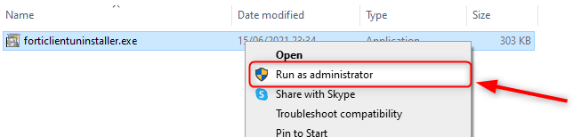

Click Yes

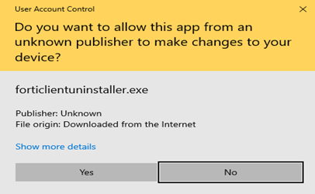

Click Yes

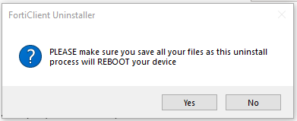

Please wait for uninstall to finish. Your laptop will reboot on completion.

Top of Form

Bottom of Form